Your Service User rights and Responsibilities

Better Together



Easy English



**Blue**

**Words**

Some words in this book are in **blue**. You can find out what these words mean at the end of this book. Go to page 13.

This book tells you about your

* **rights**

**and**

* **responsibilities**

as a Better Together Service User.



**What are your Service User responsibilities at Better Together?**

Service User responsibilities are the things that you need to do as a Better Together Service User.

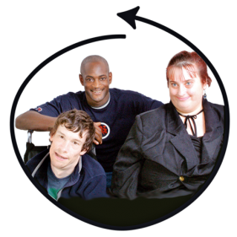

|  |
| --- |
| You must treat everyone with **respect** |

To treat a person with respect means to

* treat them well

**and**

* think about their
* feelings

**and**

* rights

Everyone should be treated with respect including

* Better Together staff

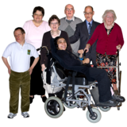**and**

* other Better Together Service Users

Treating a person with respect includes

* not using swear words at people
* not saying mean things
* not spitting at people
* not pushing

**and**

* not hitting



You have to pay for the services you get from Better Together.

Everyone at Better Together should feel safe.

You should

* speak up if you feel unsafe

**or**

* if you think that someone else is unsafe

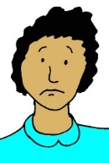If you feel

* unsafe

**or**

* think that someone else is unsafe

you can talk to your

* support worker
* service manager

**or**

* a family member

#You can also contact Better Together’s Office. You can

* call 07 54992230

**or**

* email [contact@bettertogether.net.au](mailto:contact@bettertogether.net.au)

**Your Service User rights at Better Together**

|  |
| --- |
| pic11111  You have a right to be treated as an **individual** |

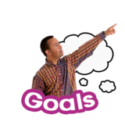This means that from Better Together you can expect that

* ****your life **goals** are
* ****understood

**and**

* **respected**
* you are supported to achieve your life goals
* you are treated
* fairly

**and**

* equally

This means to be treated just like everybody else regardless of your disability.



* You can choose how you want to live your life. This includes
* where you live
* ****who your friends are
* ****how often you see your friends
* how often you see your family
* if you want to work
* where you want to work

**and**

* what you do for fun
* you can choose to be supported by
* an **advocate**

**and**

* other **services**

|  |
| --- |
| M:\Public Relations\Images\NEW YOORALLA IMAGE LIBRARY\Easy English Images\Yooralla Equality Symbol.jpg  You have a right to expect that Better Together will work hard to make sure that people with disability are treated as equal to all other people in **society** |

Better Together will

* work with the government

**and**

* C:\Users\Tim\AppData\Local\Microsoft\Windows\Temporary Internet Files\Content.IE5\ZY0CSUQP\MC900335522[1].wmfother people

to continue to make its services better



Better Together will make sure that people know about how to make it

* better

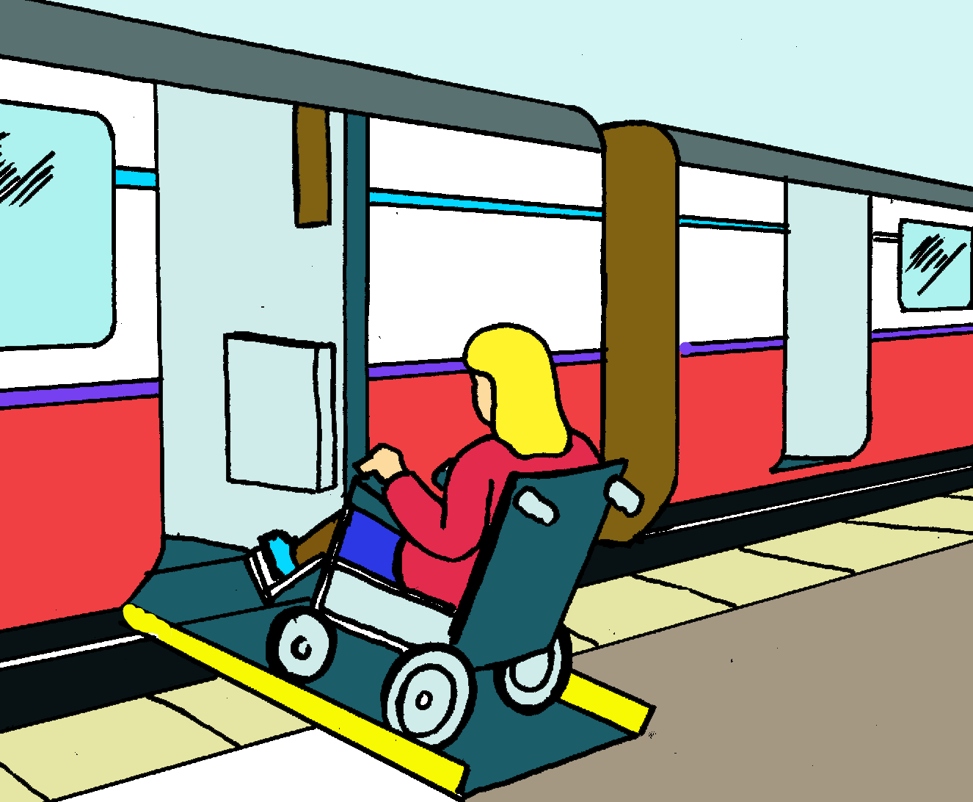**and**

* easier

for people with disability to use **public places**

These are the places where everyone can go to. For example

* 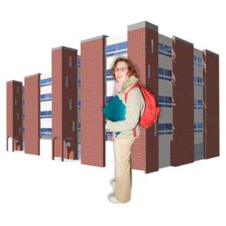libraries
* train stations
* airports
* hospitals

**or**

* swimming pools

|  |
| --- |
| You have a right to expect your **relationships** with the people who support you will be   * open   **and**   * honest |

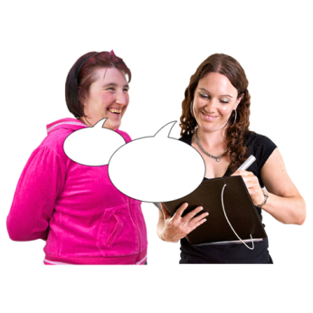This means

* getting clear **communication** about your
* **supports**

**and**

* services



* that what you pay for your services and supports
* is fair

**and**

* that you understand the **prices** of these supports and services

|  |
| --- |
| You have a right to expect good services from Better Together |

This means

* you get services that are
* good quality

**and**

* ****safe
* that Better Together gives you an easy way to
* 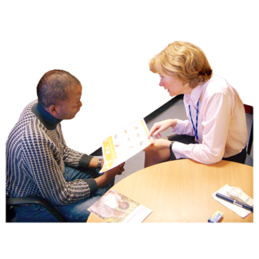make a **complaint**

**and**

* give us **feedback**

please see **Your Better Together**

**Service User Handbook** in Easy English to find out how to

* ****provide feedback

**or**

* make a complaint

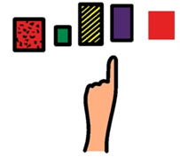

|  |
| --- |
| You have a right to make **informed choices** |

This means being supported to

* make your own decisions about your
* life
* supports

**and**

* services
* learn about different
* options

**and**

* 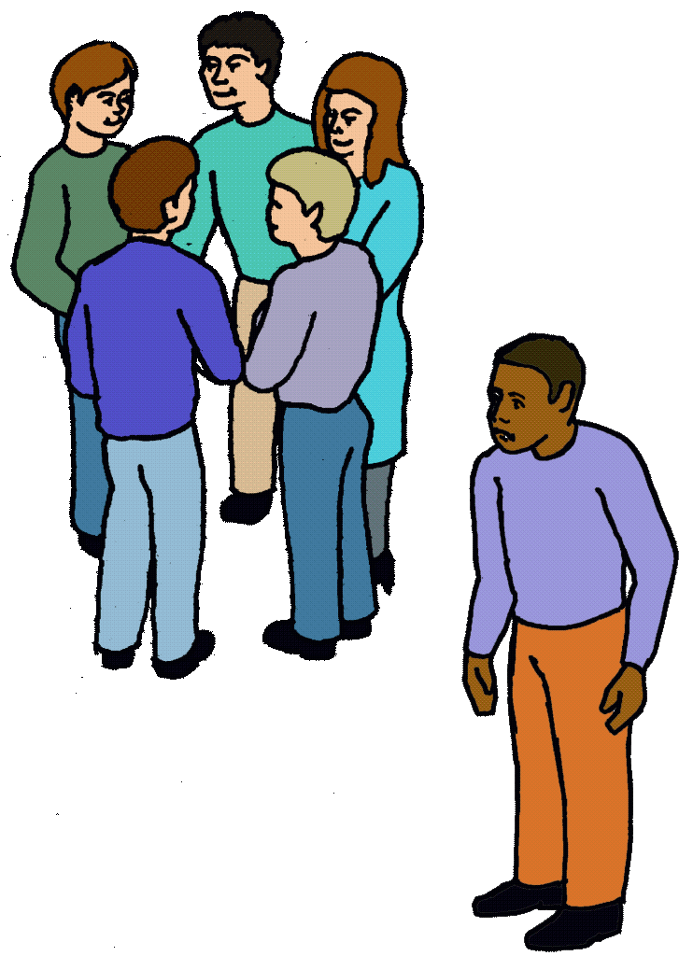services you can choose from

You can expect your supports and services to be free from

* **exploitation**
* 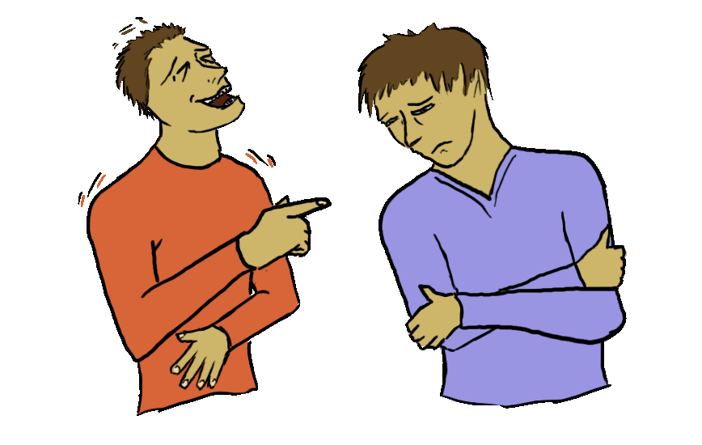**abuse**
* **discrimination**
* **harassment**

**and**

* **neglect**



|  |
| --- |
| You have a right to expect supports and services that **empower** you |

Empower means to

* support

and

* encourage you to make your own
* decisions

**and**

* choices

You can expect that Better Together will support you in your

* decisions

**and**

* choices

What the blue words mean

|  |  |
| --- | --- |
| **rights** | What all Better Together Service Users are entitled to. For example   * to be treated as an individual * to receive good quality services * to feel respected   and   * to feel safe |
| **responsibilities** | The things that you need to do as a Better Together Service User. For example   * to treat everyone with respect including * Better Together staff   **and**   * other Better Together Service Users * to pay for the services you get * speak up * if you feel unsafe   **or**   * think that someone else is unsafe |
| **individual** | A person that is   * separate from other people * with their own * needs   **and**   * goals |
| **goals** | Things in life that   * are important to you   **and**   * that you want to achieve   For example it may be   * to study * to get a job   **or**   * to volunteer |
| **respect** | To treat someone with respect means to   * treat them well   **and**   * think about their   + feelings   **and**   * + rights |
| advocate | A person who wants what is best for you.  An advocate can help you   * say what you want   **and**   * understand information   An advocate can   * listen to you * find out what you want   **and**   * what you want to do to make that happen * help you say what you need * support you to make phone calls   **and**   * go to meetings   An advocate can be a   * friend * family member   **or**   * volunteer |
| service | You pay someone to do something for you.  For example   * a support worker * a hairdresser to cut your hair   or   * a company for your mobile phone services |
| **society** | A group of people who live together in a   * country   **or**   * region   and have their own   * way of life   **and**   * rules |
| relationships | How we   * behave with other people   **and**   * relate to other people   For example   * your support worker * a nurse   **or**   * other people in your life |
| communication | The way you talk to people. The way you tell people   * what you are thinking * how you feel   or   * what you need   There are different ways to communicate. For example   * speaking * pictures   **or**   * moving your head |
| supports | The help you get with   * daily life   and   * things you want to do |
| **price** | How much money something costs. |
| **complaint** | Telling someone if you are not happy with   * a Better Together service * the way you have been treated   **or**   * someone who works at Better Together   A complaint can be   * verbal * written * formal   **or**   * informal   You can make a complaint   * within Better Together   **or**   * externally   You can ask an advocate to help you make a complaint.  Please see **Your Better Together Experience** document in Easy English to find out how to   * provide feedback   **and**   * how to make a complaint |
| **feedback** | Giving feedback means telling us what you think about   * Better Together * our service   **or**   * someone who works at Better Together   Feedback can be   * positive   **or**   * negative |
| **exploitation** | Treating someone unfairly in order to benefit from them. |
| **abuse** | Treating someone with   * cruelty   **and**   * violence   Abuse can be   * physical * verbal * financial * emotional * sexual * social   **or**   * spiritual   Abuse is against the law. |
| **discrimination** | **Discrimination** means being treated   * unfairly   **or**   * not getting what you need because you have disability |
| **harassment** | A behaviour towards another person that   * is offensive * humiliating   **or**   * intimidating   Harassment can be   * + ongoing   **or**   * + it may be just one time   Harassment because of the disability of a person is against the law. |
| **neglect** | This means someone does not get the care they need. |

The Easy English in this book was written by Better Together. in October 2019.

Images in this book are from

* Softpics © Innovative Communication Programming (Ylana Bloom   
  & Dolly Bhargava)
* Photosymbols. [www.photosymbols.com](http://www.photosymbols.com)
* Freepik. [www.freepik.com](http://www.freepik.com)