Standard 4 (Easy Read) template

About Complaints

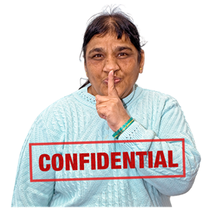 | This information is written in an easy to read way.  We use pictures to explain some ideas.  You can ask for help to read this information.  A family member, friend or support person may be able to help you.  Let us know if you would like us to help you.  This Easy Read information is a shorter version of another document.  You can ask us for a copy of the longer document.  This fact sheet is about how to make a complaint.  You have the right to complain about our service. It is ok to complain.  When things go wrong, we can learn from our mistakes and make service better.  You can make a complaint in different ways.  - You can tell someone you have a complaint  - You can write a complaint or use a complaint form.  - You can draw a picture of what went wrong  You can use any type of communication that suits you to make a complaint.  People who support you can help you to complain. This means that your family, friends or other people can complain for you.  We will keep your complaint private  Only people who try to fix the problem will be told about your complaint.  You will not be in trouble for complaining.  We will not make you feel bad for saying something is wrong with the service you use.  We will be honest and fair.  We will try to fix the problem quickly.  We will tell you what we did to fix your complaint.  We will work hard to make our service better.  This is who to contact if you have a complaint:  Sharyn McLean Assistant Manager 075499223

