Standard 1 (Easy read)

Eliminating restrictive practices

This information is written in an easy to read way.
We use pictures to explain some ideas.
Some words are written in bold. We explain what these words mean.

You can ask for help to read this information.
A family member, friend or support person may be able to help you.
Let us know if you would like us to help you.

This Easy Read information is a shorter version of another document.
You can ask us for a copy of the longer document.

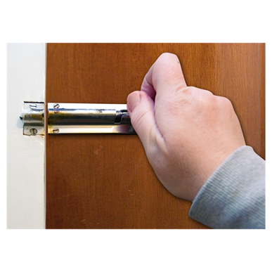
We have written this information so you know what Better Together thinks about restrictive practices.
A restrictive practice is something done to control a person’s freedom.

The information is also about how we support people who may do things that are violent or dangerous to themselves or other people.
This is sometimes called challenging behaviour.

Restrictive practices might include
- locking a person in a room
- moving a person to a room on their own
- telling a person lie down or not move until they are told to
- tying a person to furniture
- giving a person medicine to make them quiet
- stopping a person from using things they want to

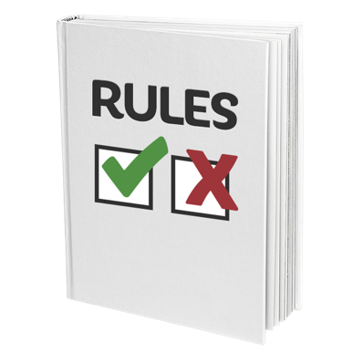

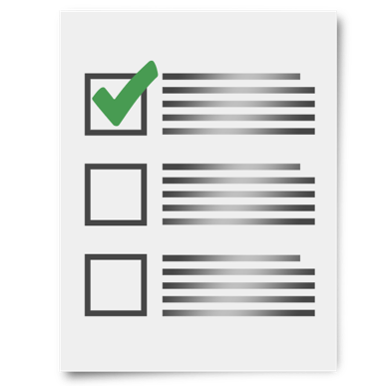
We have rules that say we will try not to use restrictive practices at all.
Restrictive practices are sometimes used when nothing else is working to stop a person’s challenging behaviours.

We know sometimes when a person behaves in a certain way, it is because there is something wrong. If you act dangerously we will work with you to understand why.

We will come up with a plan called a positive behaviour plan.
- A positive behaviour plan lists the best ways to help you manage your actions.
- A positive behaviour plan is written with you and the people who support you.
- The plan tells everyone what is ok and what is not ok.
- When your plan is new, the plan is checked by people who know a lot about positive behaviour plans and people who support you.

We train our staff in how to use your plan.

We check your plan regularly to make sure the plan is working for you and to see if any changes are needed. Restrictive practices have to be checked at least every 3 months.

If staff use a restrictive practice that is not in your plan, they need to tell the manager within 24 hours.

We keep a list of any restrictive practices we used to make sure we follow this policy and procedure.

Please let us know if you have any worries about restrictive practices. You can talk to Sharyn McLean: Assistant Manager
07 54992230

